COUNTROWS AND RELATEDTABLE FUNCTION
Question: Use COUNTROWS and RELATEDTABLE to count the rows in different tables:
Open the Power bi file in the above folder, and go to the quadrant table:

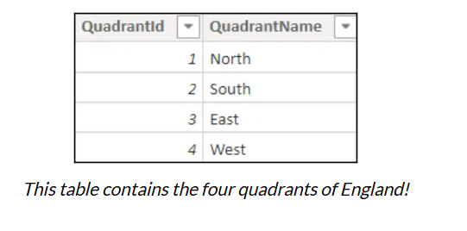
NOTE: The aim of the exercise is to add 3 new columns to this table, so that you can show this Visual:
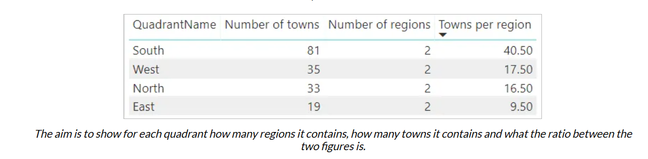

b) Starting by adding two new calculated Columns in this Table:
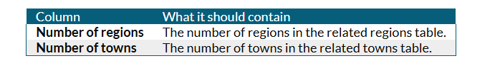
HINT: Use the COUNTROWS function to count how many rows there are in each related table.
c) Create a calculated column which tells you how many towns there are in each region, and use this to show a table of the quadrants in towns density order:

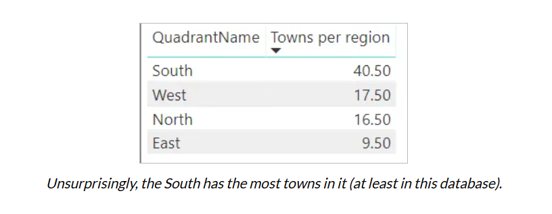
d) Save this as Go East Young Woman, then close it down.

